**Airtable Common Operations / Notes 6.19**

**Associate information across tables**

Airtable is generally a relational database, therefore it is convenient to access the associated fields in relevant tables using ‘Link to other record’ option. In this case, ‘Company’ field in ‘Deals’ table is linked to ‘Company’ table and ‘Deals’ has a lookup field ‘Department’ retrieved from the ‘Company’ table.

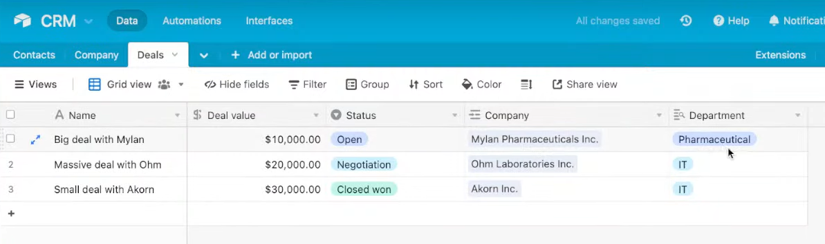

**Automation set-up**

The slack message automation example from the video mainly involves set up trigger conditions and resulting actions. In this case, once ‘Status’ field in ‘Deals’ table matches the value ‘Closed won’, automation process will be triggered to compose a Slack message and the designated channel.

**Share a subset of records and fields** (share a view)

Choose to share only selected fields or filtered values, use ‘Share View’ to only share the created view. Accessors cannot view the other fields or filtered values, nor can they change values of the view.

**Sync across projects** (a table in a project sync to another project)

Note: the sync table in another project cannot be modified, but sync to the original table.

New project tables are able to associate the fields in the sync table. Sync table can perform common operations, such as creating views, automations, etc.

**Sample automation case**

In this case, I attempted by myself to create an email sending automation, given that a field named ‘Status’ becomes ‘Done’. This auto-sent email contains some record information from the table - ‘Name’ and ‘Deadline’ - in the message body.

